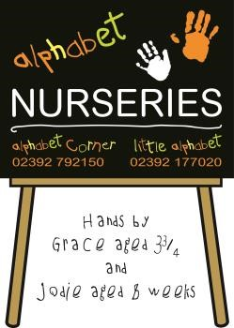

ALPHABET NURSERIES FEE SCHEDULE

From 1st March 2019

Morning  0800 – 1300 | £29.00
Afternoon  1300 – 1800 | £29.00
Full Day  0800 – 1800 | £48.00
Full Week  0800 – 1800 | £220.00
Full Week  0730 – 1800 | £230.00
Extra Hours | £6.00
0730 – 0800 | £3.50

- Morning and afternoon sessions include a light snack
- Parents/carers should provide lunch and/or tea if their child’s session/s cover/s these meal times

 | DEPOSITS
Number of Days Attended per Week |  | Deposit Required
Up to 1.5 days per week |  | £100.00
2 – 3.5 days per week |  | £150.00
4 – 5 days per week |  | £220.00

- If the number of days attended per week increases after the initial deposit has been paid, an additional deposit may be payable in line with the above
- Deposits are refunded upon termination of the placement. See Terms and Conditions of Agreement for full details.
- The Fee Schedule is applied in conjunction with our Terms and Conditions of Agreement
- The Fee Schedule is current at the above date but may be subsequently updated

Alphabet Corner, Little Alphabet & Alphabet Nurseries are trading names of Anderson & Brett Ltd
Registered in England & Wales. Registration Number 606156 Registered Office: 309 London Road, North End, Portsmouth, PO2 9HQ

